County Councillor Update  Coker Division SCC  Cllr Mark Keating  March 2021 |  | 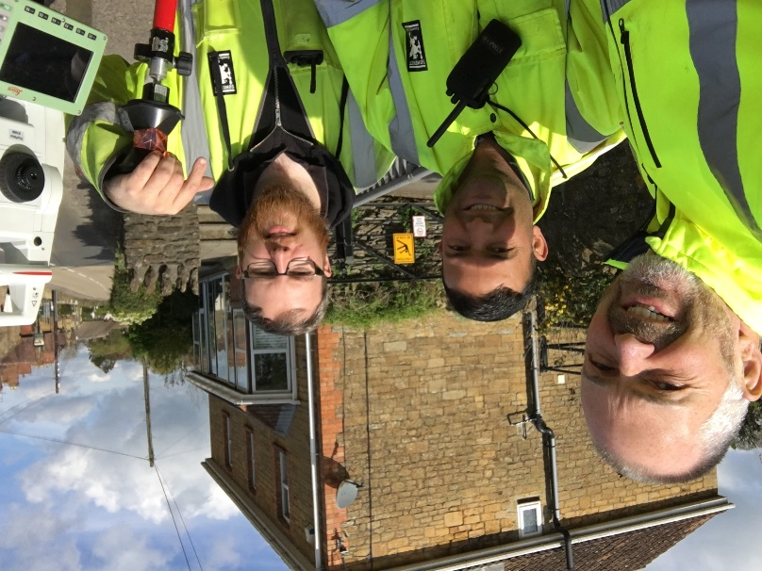
Representing you in - Barwick, Chiselborough, Closworth, East Chinnock, East Coker, Hardington Manderville, Hardington Marsh, Hardington Moor, Haselbury Plucknett, Middle Chinnock, Montacute, North Coker, North Perrott, Norton Sub Hamdon, ​Odcombe, Pendomer, Sutton Bingham, Stoford, West Chinnock, West Coker.
Useful Contacts Resources and Websites: Somerset Coronavirus Support Helpline: 0300 7906275
Cllr Mark Keating – Somerset County Council | E: MAKeating@Somerset.gov.uk | M: 07767 203968
South Somerset Area Highways Office | E: countyroads-southsom@somerset.gov.uk | T: 0300 123 2224
Report Pothole/Road Defect | E: roadsandtransportSD@somerset.gov.uk | T: 0300 123 2224
Report Dead Animal/Mud on Road | E: roadsandtransportSD@somerset.gov.uk | T: 0300 123 2224
Neil McWilliams – Highways Service Manager | E: countyroads-southsom@somerset.gov.uk | T: 0300 123 2224
Lee Norman/Derek Davies – Assist Highways Service Manager | E: countyroads-southsom@somerset.gov.uk | T: 0300 123 2224
Garry Warren/Rebecca Vaughan – Traffic Engineer. Traffic & Transport Development | E: countyroads-southsom@somerset.gov.uk | T: 0300 123 2224
Gully Emptying / Road Sweeper | E: chris.holley@southsomerset.gov.uk | T: 01935 462462
Nick Allen – SSDC Ranger Scheme | E: nick.allen@southsomerset.gov.uk | T: 01935 462462
Road Records & Highway Licensing | E: Roadrecords@Somerset.gov.uk | T: 0300 123 2224

Report Adult at Risk | adults@somerset.gov.uk |  |  | T: 0300 123 2224  T: Emergency: 999
Report Child at Risk | childrens@somerset.gov.uk |  |  | T: 0300 123 2224  T: Emergency: 999
Children’s Social Care Worker out of hours Emergency Duty Team |  |  |  | T: 0300 123 2327
Fostering and Adoption www.fosteradoptsomerset.org.uk | AandFRecruitmentEnquiryLine@somerset.gov.uk |  |  | T: 0800 587 9900
www.somersetwaste.gov.uk |  | ssdc@southsomerset.gov.uk | T: 01935 462462
https://www.travelsomerset.co.uk/ |  | Travel - Drive Bus Train Walk Cycle Weather
www.somerset.gov.uk |  | generalenquiries@somerset.gov.uk | T: 0300 123 2224
http://roadworks.org/ |  | Useful website for road works info
www.facebook.com/somersetcountycouncil |  | Somerset County Council Facebook page
https://roam.somerset.gov.uk/roam/map |  | Interactive Rights of Way Map / maintenance reporting
Pre-8th March Covid-19 Restrictions: Currently residents must stay at home, they must not leave, or be outside of their home except where necessary. They cannot leave to meet socially with anyone they do not live with or are not in a support bubble with. Residents should not travel outside their local area.
Road Map out of lockdown: From 8 March - All schools will open with outdoor after-school sports and activities allowed. Recreation in an outdoor public spaces will be allowed between two people, meaning they would be allowed to sit down for a coffee, drink or picnic. From 29 March - Outdoor gatherings of either six people or two households will be allowed including gatherings in private gardens. Outdoor sports facilities such as tennis or basketball courts will reopen and organised adult and children's sport, such as grassroots football, will also return
Coronavirus infection rates: As at 26th February the number of confirmed Covid cases in Somerset was 18,890 (up from 16,417 on 29th January) and the number of Covid-attributed deaths 722 (469). The rate per 100,000 stands at 71.5 for Somerset with Mendip at 63.2, Sedgemoor at 113.7, South Somerset 64.2 and SW&T at 52.2. The current number of total deaths across the County is currently 1% below the 5-year average and the latest R-value for Somerset is between 0.6 and 0.9. It is vitally important to remember, even those who have had a jab, to observe Hands-Face-Space at all times.

Somerset Coronavirus Support Helpline: A single phone number is available for anyone in Somerset who needs Coronavirus-related support. 0300 790 6275, is open seven days a week from 8am to 6pm.
Vaccination programme roll-out: Teams across the wider health and care system have worked round the clock at 13 GP-led community vaccination sites, two hospital hubs, two large vaccination centres (Taunton Racecourse and the Bath and West Showground) plus four local pharmacy sites. As a result Somerset has one of the highest vaccination rates in the country with the latest figures showing 194,938 having received at least their first vaccination in the County or 42% of the 16+ population. Only Dorset at 44% are above Somerset in the list of County vaccination rates.

Chinnock Hollow: Chinnock Hollow will remain closed for the time being following a landslip last week. It is essential that a safety audit is now carried out and that any works are completed before the Hollow is reopened to vehicles and pedestrians again. I am speaking with Senior Officers at Director level at SCC to ascertain why my report of June 2020 had not been taken seriously enough at that point for the Council to action a safety audit as I had requested.

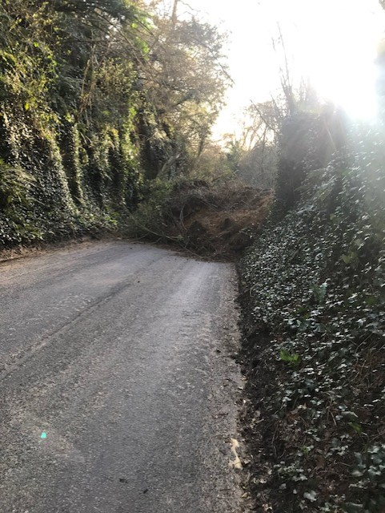
Somerset County Council Finances: SCC recently approved the budget for 2021/22 including an additional £10.2m investment into adult social care services, an additional £9m into children’s services, £6.5m on climate emergency projects, and £130m in major infrastructure schemes such as roads and schools with £74m of new projects approved. A new £10.8m Emergency Fund has been established for activities to combat coronavirus and its impacts. Importantly the budget also includes a commitment to continue the extended Free School Meals provision for vulnerable families over the Easter holidays.
Great Western Freeport: Somerset has a played a key role in the bid to develop a new Great Western Freeport – an area designed to create conditions for inward investment, business growth and job creation. The Government wants to create up to 10 Freeports around the UK, and partners including the West of England Combined Authority have submitted plans to create a Great Western Freeport. The area would include Bristol Port, the Gravity Campus (Junction 21 Enterprise Area) and Avonmouth. Gravity would focus on clean growth and attracting hi-tech companies manufacturing electric cars, artificial intelligence, and robotics. It is expected to create approximately 4,000 jobs.
Step up to social work: Somerset County Council is opening the recruitment round for aspiring social workers across the region to join the 14-month Step Up to Social Work programme, to provide training for hundreds more children and family social workers to support children and families most in need. Of the 58 places being offered across the region, 12 are being offered in Somerset. Students receive a bursary during the duration of the programme to support them whilst in training. To date eighteen new social workers have qualified in Somerset with a further ten due this year. The Step Up programme runs every two years. Applications are open until 7 April 2021.
Investing in communities: Two new Enterprise Centres have joined the Somerset network with the completion and handover of purpose-built units in Wells and Wiveliscombe thanks to Somerset County Council and partners. The Wiveliscombe centre, offers 10 two-person offices and seven small light industrial units suitable for a solo or two-person business. The centre in Cathedral Park, Wells, has 10 two-person offices and two four- person offices. It has a further five industrial units that would suit 1 to 2 people per unit.
Additional funding for Citizens Advice: During the coronavirus pandemic, Citizens Advice in Somerset have stepped up the services offered through their freephone advice line, with face-to-face appointments and drop-ins scaled back. The charities are expecting demand for services to rise exponentially over the next 12 months; particularly as the furlough scheme ends and eviction proceedings recommence. Up to £400k extra funding from Somerset County Council will be used to develop and sustain the County-wide service, to extend opening hours, and to increase capacity for the inevitable increase in demand.
One Somerset: The government has begun a public consultation into changing the way local councils work in Somerset including the County Council’s ambition to replace the county’s five existing councils with a simple, single unitary model. This would end confusion for residents, remove waste and duplication, and free up funding to invest in vital public services. It would also offer more powers for local Town and Parish Councils and one strong voice to lobby for funding and support. To take part in the Government’s consultation visit https://consult.communities.gov.uk/governance-reform-and-democracy/somerset/

